EXPT NO:4 | TRANSFORM DATA TO SUIT BI REPORTING REQUIREMENTS AND  DESIGN A DASHBOARD WITH KEY PERFORMANCE INDICATORS (KPIs ) USING TABLEAU AND POWERBI
DATE: 24.07.2026

PRE-LAB QUESTIONS (PROVIDE BRIEF ANSWERS TO THE FOLLOWING QUESTIONS)

- What is the role of data transformation in BI reporting?
Data transformation is an important step in Business Intelligence reporting because it converts raw data into a structured and meaningful format that can be easily analyzed. It improves the quality of reports by correcting data types removing unnecessary values and organizing information consistently. Transformed data produces accurate visualizations and reliable insights. It also helps users create dashboards that support better decision making by ensuring that the information presented is complete consistent and suitable for analysis.

- What are the common data cleaning techniques in Tableau and Power BI?
Tableau and Power BI provide several data cleaning techniques that improve the quality of datasets before analysis. Common methods include replacing missing values correcting incorrect data types removing duplicate records standardizing text values and formatting dates correctly. Tableau uses features such as Data Interpreter calculated fields and aliases while Power BI uses Power Query to perform data transformation and cleaning. These techniques help create accurate reports reduce errors and improve the reliability of business intelligence dashboards.

- How do Tableau and Power BI handle data aggregation?
Tableau and Power BI automatically aggregate numerical data using functions such as Sum Average Count Minimum and Maximum. Aggregation combines multiple records into summarized values that are easier to analyze and visualize. Users can also change the aggregation method depending on the reporting requirement. Tableau performs aggregation directly while creating visualizations whereas Power BI allows aggregation through visual settings DAX measures and calculated fields. This helps users summarize large datasets and generate meaningful business insights efficiently.

- What are KPIs, and why are they important in a dashboard?
Key Performance Indicators or KPIs are measurable values that indicate how well an organization or process is performing against its objectives. They provide a quick summary of important information such as total sales total cases revenue or profit. KPIs are displayed as cards or summary visuals in dashboards to help users understand overall performance without examining detailed reports. They support faster decision making improve monitoring of business activities and allow organizations to track progress toward their goals effectively.

- What are the different types of charts available in Tableau and Power BI for visualization?
Tableau and Power BI offer a wide variety of charts to represent data visually according to different analytical needs. Common visualizations include bar charts line charts pie charts scatter plots maps tree maps heatmaps area charts tables and KPI cards. Each chart highlights a different aspect of the data such as comparisons trends relationships or geographical distribution. Selecting the appropriate chart improves readability makes reports more interactive and helps users identify patterns trends and business insights more effectively.

IN-LAB EXERCISE:
OBJECTIVE:
To transform COVID-19 data into a structured format suitable for Business Intelligence (BI) reporting and design interactive dashboards with Key Performance Indicators (KPIs) using Tableau and Power BI.
PROCEDURE:
- Data Collection:
  - Import the COVID-19 dataset from inbuilt sources like Our World in Data or CSV files containing country-level COVID statistics (e.g., new cases, deaths, vaccinations).
  - Datasets may include fields such as date, location, new_cases, total_cases, new_deaths, total_deaths, people_vaccinated, etc.
- Data Cleaning and Transformation:
  - Convert columns like date to proper date formats.
  - Handle missing or null values in new_cases, total_cases, etc.
  - Create calculated fields (e.g., daily case growth rate, case fatality rate, vaccination percentage).
- Data Aggregation:
  - Aggregate data by continent, country, or month.
  - Use measures like SUM(new_cases), AVG(positivity_rate), MAX(total_deaths).
- Designing KPIs:
  - Identify KPIs such as:
    - Total Confirmed Cases o Total Deaths o Case Fatality Rate o Vaccination Coverage (%)
    - Daily Case Growth Rate
  - Use DAX (Power BI) or Calculated Fields (Tableau) to compute and visualize these KPIs.

- Dashboard Development:
  - Build visualizations such as:
    - Line charts for daily new cases and deaths o Bar charts for country-wise vaccination progress o Maps to show regional case distribution
    - KPI cards for high-level insights
  - Use filters (e.g., by continent, country) and slicers (e.g., by date range) for interactivity.
- Publishing and Sharing:
  - Publish the dashboard using Tableau Public/Server or Power BI Service.
  - Share the dashboards with stakeholders through public or organizational portals.
Experiment Dataset: COVID-19 Global Dataset
Fields Used:
  - Date – Date of the report
  - Location – Country or region
  - New Cases – Daily reported cases
  - New Deaths – Daily reported deaths
  - People Vaccinated – Cumulative vaccinated count
  - Total Cases – Cumulative confirmed cases
  - Total Deaths – Cumulative deaths
  - Population – Total population of the country

Screenshot of output from Tableau:

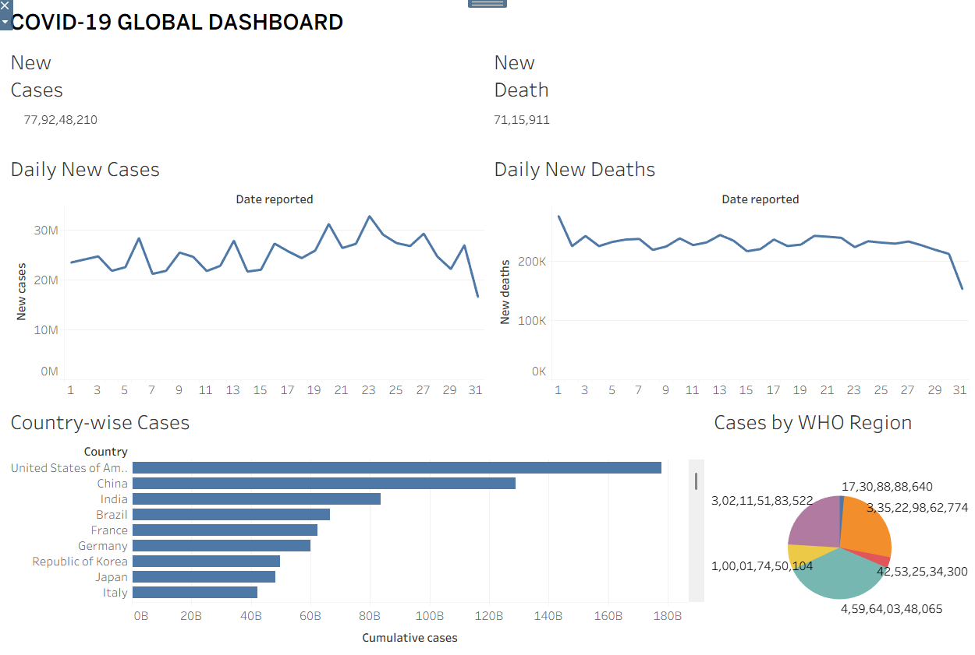

Screenshot of output from Power BI:
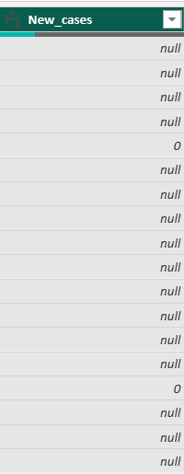
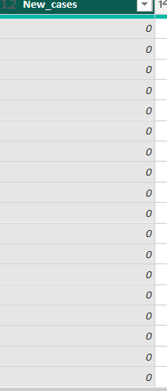
(transformed data from null to 0)

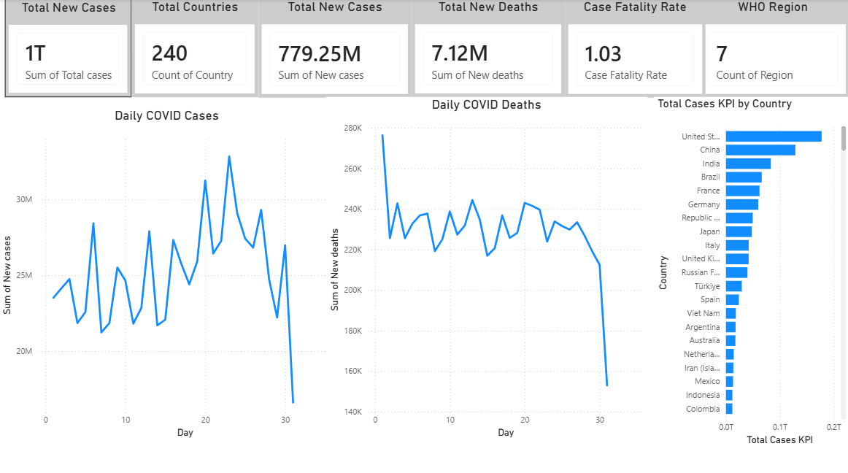

POST-LAB QUESTIONS (PROVIDE BRIEF ANSWERS TO THE FOLLOWING QUESTIONS)
  - How did data transformation improve the quality of insights in your COVID-19 dashboard?
Data transformation improved the quality of the COVID 19 dashboard by converting the dataset into a clean and structured format suitable for analysis. Missing values were handled correctly date fields were converted into proper date formats and unnecessary inconsistencies were removed. This ensured that charts and KPIs displayed accurate information without errors. The transformed dataset made it easier to analyze daily cases deaths and regional trends while improving the reliability and clarity of the final dashboard.
  - What challenges did you encounter during the data cleaning process, and how did you resolve them?
The main challenges during data cleaning included handling missing values correcting data types and ensuring that numerical fields were suitable for calculations. Some fields contained null values while date columns required proper formatting before analysis. These issues were resolved using data transformation tools available in Tableau and Power BI. Missing values were replaced with suitable defaults and the data structure was verified before creating visualizations. This process ensured that the dashboard produced accurate and meaningful insights.

  - Which KPI provided the most valuable insight, and why?
The Total New Cases KPI provided the most valuable insight because it summarized the daily spread of COVID 19 in a single value that could be easily monitored. It allowed users to understand the overall trend of new infections without examining individual records. When combined with line charts and regional filters this KPI helped identify periods of rapid growth and supported comparisons between different countries and regions. It served as an important indicator for understanding the progression of the pandemic.

  - How does interactivity in dashboards improve user experience?
Interactive dashboards improve user experience by allowing users to explore data according to their specific interests. Filters slicers and tooltips enable users to focus on selected countries regions or time periods without creating multiple reports. This flexibility makes analysis faster and more efficient while improving the understanding of complex datasets. Interactive features also encourage better decision making because users can quickly identify trends compare values and investigate important changes directly within the dashboard.

  - What steps would you take to further enhance the dashboard’s effectiveness?
The dashboard can be enhanced by adding more KPIs advanced filters and additional visualizations that provide deeper insights into the data. Including trend analysis forecasting and drill through functionality would improve exploration and decision making. Better formatting consistent color schemes and informative tooltips would make the dashboard easier to understand. Integrating more complete datasets such as vaccination statistics population and testing information would also provide a more comprehensive view of the COVID 19 situation.

RESULT:

The COVID-19 dataset was successfully cleaned, aggregated, and transformed for visual analysis using Tableau and Power BI. Missing values, data type mismatches, and inconsistencies were addressed. KPIs such as vaccination rate and daily case growth offered valuable insights into the pandemic trends across countries and timeframes. The resulting interactive dashboards allowed for effective public health monitoring and communication.

ASSESSMENT

Description |  | Max Marks | Marks Awarded
Pre Lab Exercise |  | 5
In Lab Exercise |  | 10
Post Lab Exercise |  | 5
Viva |  | 10
 | Total | 30
 | Faculty Signature

